Case 4-Greece-Cyclades-Naxos Island-Syros-Cycladic Statuette-Spedos-type, -Female

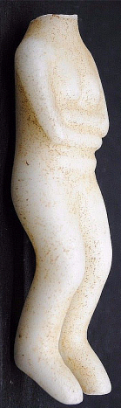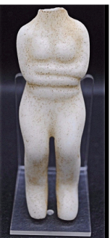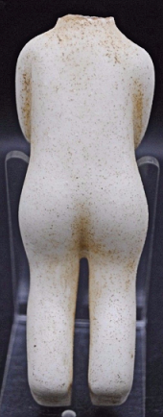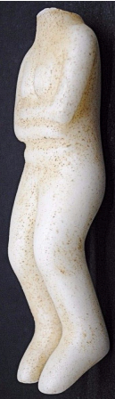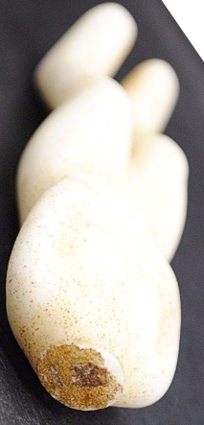

**Formal Label: Greek** Cycladic Female Statuette from the Island of Naxosdone in the Syros, Spedos-style, 2600-2300 BCE

**Accession Number:** N5899.C9

**Date or Time Horizon:** 2600-2300 BCE

**Geographical Area:** Aegean

**Cultural Affiliation:** Syros, Cycladic Island

**Medium:** marble

**Dimensions:** 103 x 32.9mm

**Weight:**

**Provenance:**

**Condition:** The crystallized inclusions of a ferric compound testify to it having been in a burial context for thousands of years. The fractured neck also has these inclusions, which indicates that it was damaged in antiquity.

**Discussion:** This Cycladic culture female statuette from the Island of Naxos in the Spedos style dates to 2600-2300 BCE. Many similar buried Spedos statues like this have been found in grave sites and are believed to be a devotional artifact for the deceased. Between 3200 and 2000 B.C a highly developed culture flourished on the Cyclades archipelago in the Aegean Sea. There were fortified, heavily populated settlements, prosperous through sea trade. The art of sculpting was one of the most important aspects of this early culture. The sculptures were mostly executed in beautiful white marble that was amply available on the islands. The touching, stylized female figurines appeal the most to ones with an artistic imagination. These Female Figurines are always portrayed as standing nudes, their arms crossed over their pregnant belly. Their faces are smoothed down, angular on the top and round at the bottom. Only the nose is sculpted.  The Cycladic art of sculpting is classified in three types, based on chronology and style. This statuette is done in the Spedos type, named after a burial site on the island of Naxos, and is the one most well-known. Little is known about the exact meaning of the female figurines. Some decorations seem to indicate an association with motherhood and fertility. Many of the figurines are found on burial sites which leads to the assumption that they were used during funeral ceremonies. Famous European artists like Moore, Picasso and Modigliani have been inspired by this completely unique style.

**References:**

Ḏoumas, Christos. C*ycladic art : ancient sculpture and ceramics of the Aegean from the N. P. Goulandris Collection*; [translated by Alexandria Doumas].

Fitton, J. Lesley. 1990. Cycladic art. London: British Museum.

Sherratt, Susan. 2000. *C****atalogue of Cycladic antiquities in the Ashmolean Museum*.** Oxford ; New York : Oxford University Press. 2 v. v. 1. Text -- v. 2. Illustrations.